

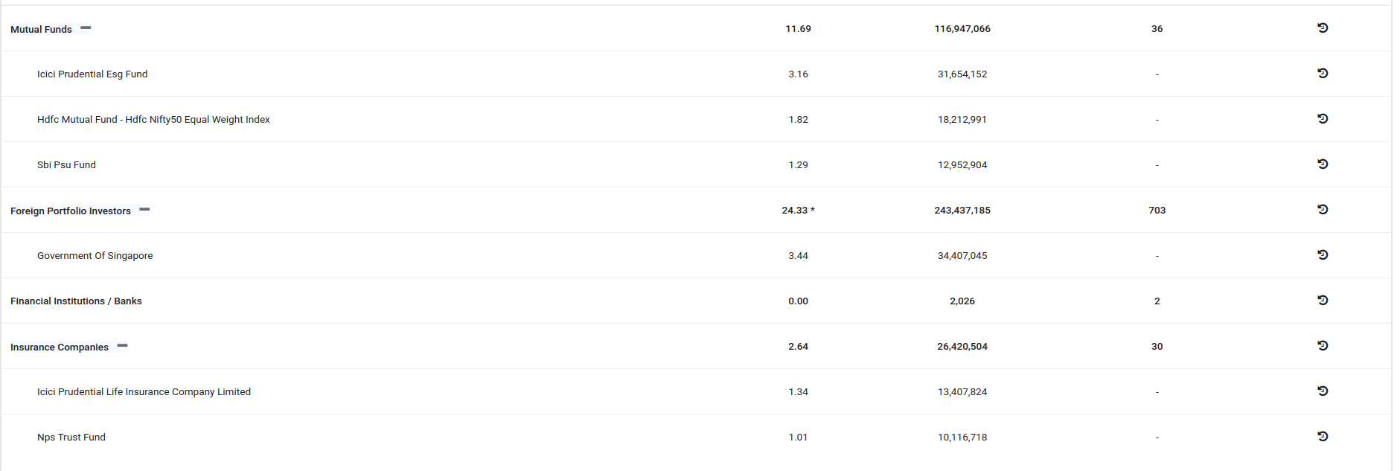

| **NAME** |  | | **%** | **Shares** | **NO OF HOLDERS** |
| --- | --- | --- | --- | --- | --- |

| [State Bank Of India](https://trendlyne.com/portfolio/superstar-shareholders/custom/?query=state%20bank%20of%20india) | 55.46 | 555,000,000 |  |  |
| --- | --- | --- | --- | --- |

| Mutual Funds | 11.69 | 116,947,066 | 36 |  |
| --- | --- | --- | --- | --- |
| [Icici Prudential Esg Fund](https://trendlyne.com/portfolio/superstar-shareholders/custom/?query=icici%20prudential%20esg%20fund) | 3.16 | 31,654,152 | - |  |
| [Hdfc Mutual Fund - Hdfc Nifty50 Equal Weight Index](https://trendlyne.com/portfolio/superstar-shareholders/custom/?query=hdfc%20mutual%20fund%20hdfc%20nifty50%20equal%20weight%20index) | 1.82 | 18,212,991 | - |  |
| [Sbi Psu Fund](https://trendlyne.com/portfolio/superstar-shareholders/custom/?query=sbi%20psu%20fund) | 1.29 | 12,952,904 | - |  |
| Foreign Portfolio Investors | 24.33 * | 243,437,185 | 703 |  |
| [Government Of Singapore](https://trendlyne.com/portfolio/superstar-shareholders/custom/?query=government%20of%20singapore) | 3.44 | 34,407,045 | - |  |
| Insurance Companies | 2.64 | 26,420,504 | 30 |  |
| [Icici Prudential Life Insurance Company Limited](https://trendlyne.com/portfolio/superstar-shareholders/custom/?query=icici%20prudential%20life%20insurance%20company%20limited) | 1.34 | 13,407,824 | - |  |
| [Nps Trust Fund](https://trendlyne.com/portfolio/superstar-shareholders/custom/?query=nps%20trust%20fund) | 1.01 | 10,116,718 | - |  |

| Individual share capital in excess of Rs. 2 Lacs | 0.34 | 3,414,961 | 42 |
| --- | --- | --- | --- |

| Any Other | 0.09 | 895,733 | 9,132 |  |
| --- | --- | --- | --- | --- |
| [Huf](https://trendlyne.com/portfolio/superstar-shareholders/custom/?query=huf) | 0.06 | 601,272 | - |  |
| [Trusts](https://trendlyne.com/portfolio/superstar-shareholders/custom/?query=trusts) | 0.02 | 207,261 | - |  |
| [Clearing Members](https://trendlyne.com/portfolio/superstar-shareholders/custom/?query=clearing%20members) | 0.01 | 87,200 | - |  |
| [Macritchie Investments Pte Ltd](https://trendlyne.com/portfolio/superstar-shareholders/custom/?query=macritchie%20investments%20pte%20ltd) | 1.51 | 15,100,000 | - |  |